Architectural Review Checklist

caIntegrator2 – Computational Machine

Version 1

Revision Document History
Date | Version | Description | Author
06/15/07 | 0.5 | First draft | NCI CBIIT Dedicated Support

Table of Contents
1. Introduction 6
1.1 Purpose 6
1.2 Guidelines for Completing the ARC 6
2. Project Details (To be answered by development team) 6
2.1 General Information 6
2.1.1 Project Description 6
2.1.2 Contact Information 7
2.1.3 Major Deployment Milestones 7
2.2 Architectural Details 7
2.2.1 High level architectural description: 7
2.2.2 High Level Design Diagram (If available): 7
2.2.3 Implementation language(s) used? 7
2.2.4 Will connections/requests to the application be session based (i.e. statefull versus stateless)? If so, is there any reason why application would not support “sticky session” load balancing? 7
2.2.5 Will the application be caching data? If so, what is being cached and how much data will be cached? 7
2.2.6 What data files will be created (if any)? How much data will be saved on an on going basis? 7
2.2.7 Will this application need a database schema(s) created on the NCICB infrastructure? If so, what is the maximum number of objects to be stored? 8
2.2.8 Are there any external/non-NCICBIIT data sources that will be accessed by the application? 8
2.2.9 If this is a web-based application, what are the preferred virtual hosts names to be registered? 8
2.2.10 Any additional architectural details that may be of significance to the needed deployment environment. 8
2.3 Performance Requirements 8
2.3.1 Total number of users for this application? 8
2.3.2 Peak number of concurrent users? 8
2.3.3 Peak number of requests/minute? 8
2.3.4 Up time requirements? 8
2.3.5 Acceptable down time when recovering from major systems disaster? 8
2.4 NCICB Project Dependencies 8
2.5 Configuration Management Details 8
2.5.1 Version Control 8
2.5.2 Change Control 8
2.5.3 Migration to CVS 8
2.5.4 Users 9
2.5.5 Build Process 9
2.5.6 Other CM Needs 9
2.6 Additional Notes 9
3. System Requirements (To be answered by both development & systems team) 9
3.1 Operating System 9
<<Solaris/LINUX/Windows 2000/…>> 10
3.2 Software (Technology Stack) 10
3.2.1 Web Server: <<Apache/Tomcat/ZOPE/…>> 10
3.2.2 App Server: <<Tomcat/JBoss/Oracle 9iAS/…>> 10
3.2.3 Database Server: <<Oracle/MySQL/PostgreSQL/…>> 10
3.2.4 Other software components: <<PERL x.x, MatLab x.x, R x.x, …>> 10
3.3 Server Hardware 10
3.3.1 Server: <<type, model, …>> 10
3.3.2 Minimum processor speed: 10
3.3.3 Minimum memory: 10
3.3.4 Minimum local drive space: 10
3.4 Storage 10
3.4.1 Expected file server disk storage (in MB): 10
3.4.2 Expected database storage (in MB): 10
3.4.3 Expected ftp storage (in MB): 10
3.4.4 Expected media/image storage (in MB): 10
3.5 Load Balancing/Fault Tolerance 10
3.5.1 Does the application support load balancing? 10
3.5.2 Implement load balancing – YES/NO 10
3.6 Networking 11
3.6.1 Any application specific port assignments? 11
3.6.2 Any additional configuration? 11
3.7 Additional Notes 11
4. Proposed NCICB Deployment Environment (To be answered by systems team) 11
4.1 Hardware 11
4.2 Technology Stack 11
4.3 File Server 11
4.4 Database 11
4.5 Networking 11
4.6 Other Resources 11
5. Impact Assessment (To be answered by systems team) 11
5.1 Overview 11
5.2 Cost 11
5.3 Timeline to implement 11
5.4 Additional Notes 12
6. Acceptance 12
7. Appendix 1 - Future Systems Requirements 13
7.1 New Architecture Diagram 13
7.2 Notes on the design change 13
7.3 Hardware 13
7.3.1 Servers 13
7.3.2 Processor speed 13
7.3.3 Memory 13
7.3.4 Drive Space 13
7.4 Software (Technology Stack) 13
7.4.1 Web Server 13
7.4.2 App Server 13
7.4.3 Other components 13
7.5 Fault Tolerance (Redundancy) 13
7.5.1 Does the application support load balancing? 13
7.5.2 Implement load balancing – YES/NO 13
7.5.3 Load balancing requirements 13
7.5.4 Fault tolerance solution suggested 13
7.5.5 Additional requirements (if any) 13
7.6 Performance Enhancements 13
7.6.1 Processing Power 13
7.6.2 Memory 13
7.6.3 I/O 13
7.6.4 Other needs 13

Introduction

Purpose
The purpose of the Architectural Review Checklist (ARC) is to help identify the deployment environment (both hardware and software components) necessary for an application to execute optimally within the NCI CBIIT IT infrastructure. The ARC is considered to be a dynamic artifact for any NCI CBIIT project and should be maintained in the configuration library (i.e. CVS) for each project. For new projects, this document template will be automatically checked into the projects repository by the SCM team upon project initiation. The ARC should be reviewed on at least a quarterly basis to capture any application design changes that may effect the deployment environment necessary for optimal performance.

Guidelines for Completing the ARC
The ARC is divided into 4 main sections. The first section (Project Details) is meant to capture general information about the project. The project development team should fill out the Project Details section and return it to the systems team. The second section (Systems Requirements) is meant to capture details of specific system requirements for the project. Both the development and system teams will preferably answer the Systems Requirement section jointly. However, depending on the development team’s familiarity with the NCI CBIIT infrastructure, they may choose to answer either all or parts of this section on their own. The third section (Planned Deployment Environment) specifies the proposed deployment environment for the application and is to be answered by the systems team based on the response to section 1 & 2. Finally, the last section (Impact Assessment) describes the impact (additional hardware/software costs, staffing resources…) to the existing NCI CBIIT IT infrastructure in order to support this application. Upon completion of the Deployment Environment and Impact Assessment sections, the systems team will return the ARC to the development team for final review and comments.

Project Details (To be answered by development team)

General Information

Project Description
caIntegrator2 is a web-based software package that allows researchers to set up custom, caBIG®-compatible web portals to conduct integrative research, without requiring programming experience. These portals bring together heterogeneous clinical, microarray and medical imaging data to enrich multidisciplinary research. Using caIntegrator2, researchers can execute, save and share queries to identify and collect many types of data, combining clinical information with genetic and genomic data to enable multidimensional analysis. caintegrator2 uses caGrid analytical services such as GenePattern and BioConductor to perform analysis on the integrated study data, including clinical survival data. caIntegrator2 leverages the Cancer Data Standards Registry and Repository (caDSR) to map experimental data to well-defined datatypes and utilizes caGrid and Java client APIs to access data from caBIG® applications such as caArray, the National Biomedical Imaging Archive (NBIA). caIntegrator is also integrated with caBIO to perform queries on genes and pathways.
CaIntegrator2 requires powerful machines to handle several data processing required as a part of a study deployment as well as end user analysis. Current analysis and pre-processing includes usage of Bioconductor and GenePattern. Application uses grid interface as well as stand-alone application to do analysis on Bioconductor and GenePattern. The computational machine will be used by the data piplines to create a study in caIntegrator as well as analysis pipelines to complete analysis for end-user.

Contact Information
Title | Name | Phone | Email
Product Manager | Anand Basu | (301) 437-4165 | basuan@mail.nih.gov
Project Manager | Shine Jacob | (301)443- 6856 | Jacobss2@mail.nih.gov
Tech Lead | JP Marple | (301) 443- 6025 | marplej@mail.nih.gov

Major Deployment Milestones
Milestone | Date
Planned Release to QA | Nov 2009
Planned Release to Staging | Dec 2009
Planned Release to Production | Dec 2009

Architectural Details

High level architectural description:

Computational machine will be primarily used by caIntegrator2 application to run analysis. The analysis services are provided by two third-party applications – Bioconductor and GenePattern.

caIntegrator2 will mostly use a grid exposed services of Bioconductor. caIntegrator2 development team may use bioconductor non-grid services of bioconductor.
In future, caIntegrator2 will use GenePattern (both grid and SOAP API) on this server.

Details of Bioconductor and GenePattern are given below.

- Bioconductor is an open source and open development software project for the analysis and comprehension of genomic data. More information is available at http://www.bioconductor.org/
- The Genepattern server is a product of the Broad Institute at MIT. It provides extensive set of modules for the analysis and visualization of genomic data (http://www.broad.mit.edu/cancer/software/genepattern/) The Genepattern server will complement the caIntegrator2 by providing a large number of analysis and visualization modules.
Refer ARC document for GenePattern for caIntegrator2 at https://gforge.nci.nih.gov/svnroot/caintegrator2/trunk/docs/deployment/GenePattern%20Architectural%20Review%20Checklist.doc

High Level Design Diagram (If available):
A representation of how caIntegrator2 will be using this machine is shown below.

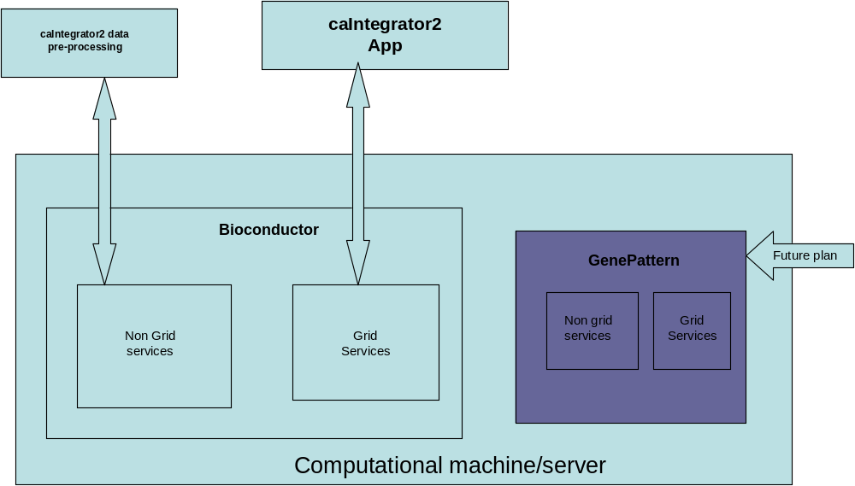

Bioconductor installation instructions are available at
http://www.bioconductor.org/docs/install/
Bioconductor technical guides are available at
https://gforge.nci.nih.gov/svnroot/caintegrator2/trunk/docs/implementation/references/bioconductor/Bioconductor-technical-guide.doc
Bioconductor grid installation instructions are available
https://gforge.nci.nih.gov/docman/view.php/175/12460/Installation_Guide.doc
caIntegrator2 team doesn’t believe that this document is complete. An update to the above documentation based on caIntegrator2 team’s experience is available at
https://gforge.nci.nih.gov/svnroot/caintegrator2/trunk/docs/implementation/references/bioconductor/dev_grid_instance_config_notes.rtf

Implementation language(s) used?

This will be an installation of BioConductor. At a later time, GenePattern will be installed.
R will be used if any specific customization is required.

Will connections/requests to the application be session based (i.e. statefull versus stateless)? If so, is there any reason why application would not support “sticky session” load balancing?
No session maintenance is required.

Will the application be caching data? If so, what is being cached and how much data will be cached?
We do not expect any data caching, except at run-time. Once the job is completed, data is stored in caIntegrator2 server/db.

What data files will be created (if any)? How much data will be saved on an on going basis?

Except for any data pre-processing required by caIntegrator2 team, we don’t anticipate much data storage.
20GB of storage is sufficient based on current needs.

Will this application need a database schema(s) created on the NCICB infrastructure? If so, what is the maximum number of objects to be stored? No

Are there any external/non-NCICB data sources that will be accessed by the application?
No

If this is a web-based application, what are the preferred virtual hosts names to be registered?

The plan is to have the server only be accessible by going through a caIntgrator2 application. For example, the user would log into caIntegrator2 and then from within a into caIntegrator2 link to this server. We do not plan to have the services on this server accessible without going through caIntegratior2.

Any additional architectural details that may be of significance to the needed deployment environment.
Grid installation of bioconductor is not documented correctly yet. This may bring some challenges to complete successful installation.

Performance Requirements

Total number of users for this application? 300+

Peak number of concurrent users? 100+

Peak number of requests/minute?

Up time requirements? Ideally 24/7, but weekend/late evening (EST) maintenances are acceptable

Acceptable down time when recovering from major systems disaster? Within 24 hrs

NCI CBIIT Project Dependencies

Configuration Management Details
Briefly describe your current configuration management practices here.

Version Control
What version control software are you currently using, if any?
SVN

Change Control
What are your current change control practices? What procedures are in place to determine whether to implement a change request?
After Customer Approval, Changes are deployed on QA for testing. Next forwarded to
Staging and then to Production.

Migration to CVS
Indicate whether you will require SCM support migrating your source code to the NCICBIIT CVS repository.
no

Users
Provide a list of all developers who require access to your repository modules.
JP Marple
Huaitian Liu
Shine Jacob
Ngoc Nguyen
TJ Andrews
Anand Basu

Build Process
Describe your build process here. For example, are you using Ant, Make, or something else?
No

Other CM Needs
Describe any other CM needs?

Additional Notes

At this time we are aware that for the grid installation of Bio-conductor, the following pre-requisites are required
- Install Apache Ant 1.7.0
- Install caGrid 2.0,
- Install A Java SDK 1.5.x:

System Requirements (To be answered by both development & systems team)

Operating System

Linux SuSE, Red Hat, Mandrake
Other Unix Solaris, AIX, Tru64

Software (Technology Stack)

Web Server:

App Server:

Database Server:

Other software components:

Server Hardware

Server:

Minimum processor speed: Not exactly sure, some of the Genepattern jobs can be quite compute intensive. In general the Genepattern jobs are more compute intensive than the current analysis server jobs.

Minimum memory: 64 GB

Minimum local drive space: Estimate 20 Gig of space .

Storage

Expected file server disk storage (in MB):Estimate 20 Gig

Expected database storage (in MB): NA

Expected ftp storage (in MB): NA

Expected media/image storage (in MB) NA

Load Balancing/Fault Tolerance

Does the application support load balancing? Not sure, never tested it

Implement load balancing – YES/NO, No problems if we can test it on staging first

Networking

Any application specific port assignments? caIntegratorApps need to know what URL to use to connect to the Biocondutor server. The systems team can assign the port numbers and communicate the information to the development team.

Any additional configuration?

Additional Notes

Proposed NCICB Deployment Environment (To be answered by systems team)

Hardware
<<dev, qa, staging, production servers to be used>>

Technology Stack
<<specific technology stack to be used>>

File Server
<<space allocation on big IP, NFS mount points, initial size allocation…>>

Database
<<database server to used, schema names to be created, initial size, maximum size…>>

Networking
<<e.g. any BigIP configuration necessary, …>>

Other Resources
<<e.g. ftp server access, media server access, …>>

Impact Assessment (To be answered by systems team)

Overview

Cost

Timeline to implement

Additional Notes

Acceptance
Project Lead ( ) | Project Coordinator – NCICB ( )
Systems Team | SCM Administrator

Appendix 1 - Future Systems Requirements
New studies will need additional resources (disk and cpu) .

New Architecture Diagram

Notes on the design change

Hardware

Servers

Processor speed

Memory

Drive Space

Software (Technology Stack)

Web Server

App Server

Other components

Fault Tolerance (Redundancy)

Does the application support load balancing?

Implement load balancing – YES/NO

Load balancing requirements

Fault tolerance solution suggested

Additional requirements (if any)

Performance Enhancements

Processing Power

Memory

I/O

Other needs

